**PROJECT TITLE**

**A Major Project Report**

**Submitted in Partial fulfillment for the award of**

**Bachelor of Technology in Computer Science & Engineering**

Submitted to

**RAJIV GANDHI PROUDYOGIKI VISHWAVIDYALAYA**

**BHOPAL (M.P)**



**MAJOR PROJECT REPORT**

Submitted by

Student Name 1[Roll No.]Student Name 2[Roll No.]

Student Name 3[Roll No.] Student Name 4[Roll No.]

Under the supervision of

Guide Name

Designation



   

**Departmet of Computer Science & Engineering**

**Lakshmi Narain College of Technology, Bhopal (M.P.)**

**Session**

**Jan 2021**

LAKSHMI NARAIN COLLEGE OF TECHNOLOGY, BHOPAL

**DEPARTMENT OF COMPUTER SCIENCE & ENGINEERING**



### CERTIFICATE

This is to certify that the work embodied in this project work entitled **”Project Title”** has been satisfactorily completed by the **Student Name 1** (Roll No.), **Student Name 2** (Roll No.) , **Student Name 3** (Roll No.), **Student Name 4** (Roll No.). It is a bonafide piece of work, carried out under the guidance in **Department of Computer Science & Engineering**, **Lakshmi Narain College of Technology, Bhopal** for the partial fulfillment of the **Bachelor of Technology** during the academic year 2020-2021.

## Guide Name

Designation  **(GUIDE)**

Approved By

**Professor & Head**

# Department of Computer Science & Engineering

LAKSHMI NARAIN COLLEGE OF TECHNOLOGY, BHOPAL

**DEPARTMENT OF COMPUTER SCIENCE & ENGINEERING**

**Acknowledgement**

We express our deep sense of gratitude to Prof. ……………………. (Guide) department of Computer Science & Engineering L.N.C.T., Bhopal. Whose kindness valuable guidance and timely help encouraged me to complete this project.

A special thank goes to Dr. Bhupesh Gour (HOD) who helped me in completing this project work. He exchanged his interesting ideas & thoughts which made this project work successful.

We would also thank our institution and all the faculty members without whom this project work would have been a distant reality.

**Signature**

Student Name 1[Roll No.] Student Name 2[Roll No.]

Student Name 3[Roll No.] Student Name 4[Roll No.]

**INDEX**

|  |  |  |
| --- | --- | --- |
| **S.NO.** | **TOPICS** | **PAGES** |
|  | Introduction | 1-2 |
|  | Problem Domain Description | 1-2 |
|  | Major objective & scope of project | 2-3 |
|  | Hardware/Software platform environment | 2-3 |
|  | Proposed designed and methodology | 3-5 |
|  | Project limitation and Future scope | 2-3 |
|  | References | 2-3 |
|  | Total Approx. 15-20 Pages | |

**Instruction for Submission of Project Report**

**Final Year CSE**

**The Project Report should be in Spiral Binding with following instructions**

**The front page should be Glossy and colored**

1. Chapter Name - Number : 14 (Times New Roman & All Capital Latters)
2. Heading : 16 (Times New Roman & First Latter Capital)
3. Sub Heading : 14 (Times New Roman & FLC)
4. Matter : 12 (Times New Roman )
5. The report should be indexed and pages must be numbered all the figures and diagrams must be numbered and labeled.

**Note:-** The title should not be very short. It must be explanatory which should include, Problem to be solved, Solution of the given problem (in terms of some Algorithm/Design/Technique used in solving it) and language/platform used for developing the solution for the identified problem like python , java etc.

Example:-

1. **Web Based Graphical Password Authentication System using JAVA**
2. **Identification and Matching of Robust-Face Name Graph for Movie Character**
3. **Controlling of Topology in Ad hoc Networks by Using Cooperative Communications**
4. **An SSL Back End Forwarding Scheme of Clusters Based On Web Servers**
5. **Motion Extraction Techniques Based Identifying the Level of Perception Power from Video**
6. **Approximate and Efficient Processing of Query in Peer-to-Peer Networks**

**Note: Next page gives Template for making project file**

**CHAPTER 1**

**INTRODUCTION**

1. **Heading**

This template, modified in MS Word 2007 and saved as a “Word 97-2003 Document” for the PC, provides authors with most of the formatting specifications needed for preparing electronic versions of their papers.

**1.1.1 Sub Heading**

The template is used to format your paper and style the text. All margins, column widths, line spaces, and text fonts are prescribed; please do not alter them. You may note peculiarities.

## *A) Sub Sub Heading*

Positioning Figures and Tables: Place figures and tables at the top and bottom of columns. Avoid placing them in the middle of columns. Large figures and tables may span across both columns. Figure captions should be below the figures; table heads should appear above the tables. Insert figures and tables after they are cited in the text. Use the abbreviation “Fig. 1”, even at the beginning

1. Table Type Styles

| Table Head | Table Column Head | | |
| --- | --- | --- | --- |
| Table column subhead | Subhead | Subhead |
| copy | More table copya |  |  |

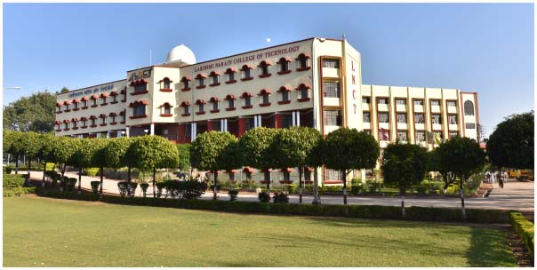

1. Example of a figure caption. (*figure caption*)